**BMBA - The BEEF Shooting Method in Basketball (For Youth Players)**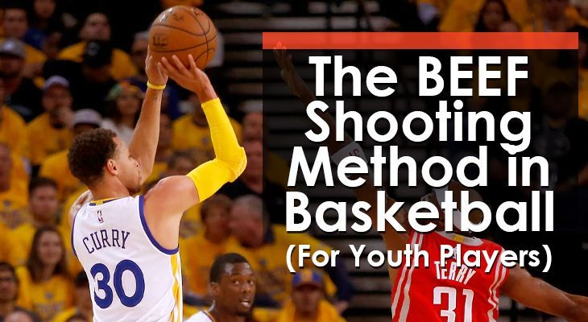

If you were to ask 10 kids what basketball player they most want to be like, at least 9 of them would most likely put Stephen Curry at the top of their list, the man is a shooting phenomime.

It’s no secret that in today’s game outside shooting has become a highly-desired skill in modern basketball.

Walk into any gym and you’ll see young players throwing up long-distance 3-pointers way before they’ve developed the technique or strength to do so effectively and equally as important, consistently.

It’s a fun skill to practice, but learning how to shoot properly is no easy task and as such its important at young ages we teach correct form to all young aspiring ballers, it is widely agreed you should commence all young players by recommending the BEEF shooting method.

It’s simple to learn, easy to remember, and effective to practice the basics and hopefully this article will help explain what that is and how to teach it.

**The BEEF Shooting Method -** “BEEF” is an acronym for the four major components of correct shooting.

It stands for **Balance, Eyes, Elbow, and Follow-through**.

So, let’s go over each one to see how they should be taught to players.

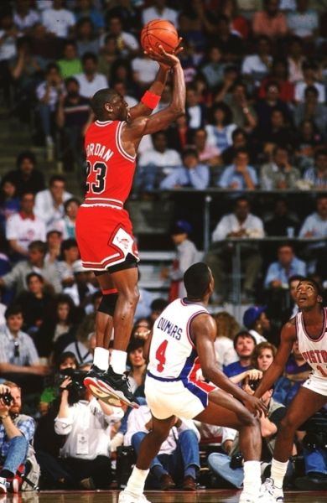**B = Balance** - which is thefoundation for a good stance…   
a player’s shooting stance and knee push follow through is critical.

The BEEF system does not have a rigid blueprint for stance. Instead, it has a set of principles to keep in mind and consistency is probably the most important one, successful shooting comes from a standard process ensuring each shot taken is the same, now while this is difficult to achieve in young players it is a must, if they wish to become better shooter over time.

The feet should be approximately shoulder-width apart, with the lead foot a little in front of the other foot but again balance is critical.

The knees should be slightly bent for stability and act as springs to generate the push power that will elevate the ball towards the ring. Your knees do the work your hands/fingers direct the ball to your target.

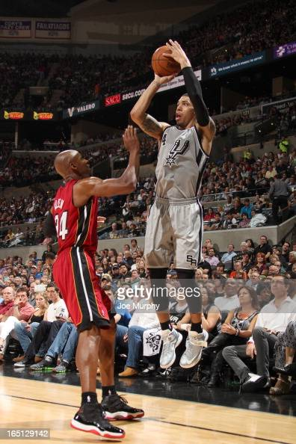**E = Eyes** - and as the name suggests, this part is all about getting players to focus their eyes and in regards to what the eyes should be focused on, there isn’t one correct answer.

But over time each player will as part of developing their shooting process pick that target which helps them best concentrate and allows them to focus accordingly. I suggest the nearest or front part of the ring as a starting point.

The main thing for each player is to stick to one point/target to allow their shot to become consistent in its approach.

**E = Elbow -** there are two main components of every shot, (1) power and (2) accuracy, with the balance and your knees generating the power and elbow and wrist snap is responsible for accuracy.

The key is then the alignment as players need the shooting eye, the shooting hand + elbow, and the rim all on the same line.

This will ensure maximum accuracy and while keeping you on line it also minimises any misses to the side.

As the ball moves up on a shot attempt, the shooting hand and elbow come under the ball and align with the hoop (the elbow should not flare out to the side).  
  
Once the set point is reached, the wrist should be cocked and form an approximately 90-degree angle with the forearm.

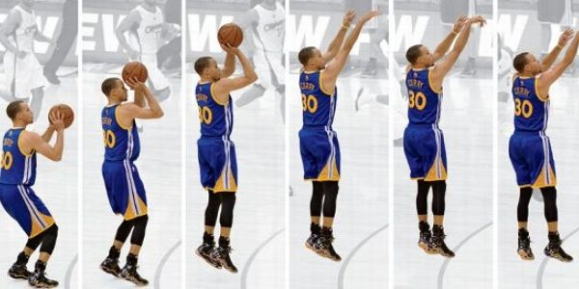**F = Follow Through -** the shot and the release…as a player pushes up through the shot, they must ensure the wrist snaps and the ball is released at the same time that their elbow reaches full extension.

If done correctly, the ball will roll off their index + middle fingers and produce perfect backspin, todays coloured balls allow you to monitor the spin quite easily, so don’t forget to have a regular look at it.

Know you must keep the wrist softly flexed after the ball leaves your hand and keep your arm extended.

Another thing to note…don’t push the ball with your off-hand / guide hand. For a right-handed shooter, the left hand’s only purpose is to keep the ball stable until the release motion starts and vice versa for a lefty.

**So what’s the Next Step...**

The BEEF method of shooting is an effective shooting method for young players because it doesn’t overwhelm them with details before they’ve mastered the basics and if they can get these basics correct while they are young, then they are generally assured their shooting technique will continue to improve over time.

However to become an elite shooter it takes a lot of time, practice and especially building a good technique – so as with most skills it takes a lot of work to develop and even more work to get better – so good luck and just remember to keep practicing !

For any further BEEF information, please refer to this link: [**https://www.youtube.com/watch?v=uYTXkHSV1UE**](https://www.youtube.com/watch?v=uYTXkHSV1UE)